Find all details regarding salesman and order for customer co1.

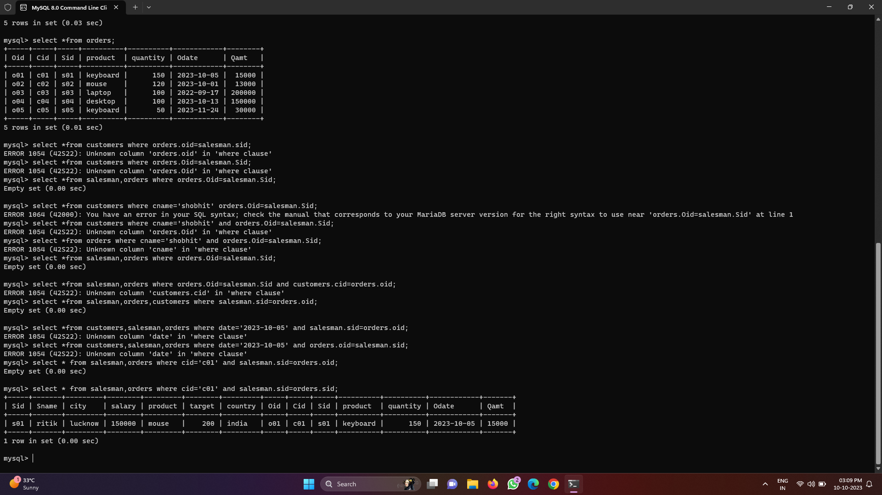

Find the name of salesman who sold product on ‘ xyz’ date.

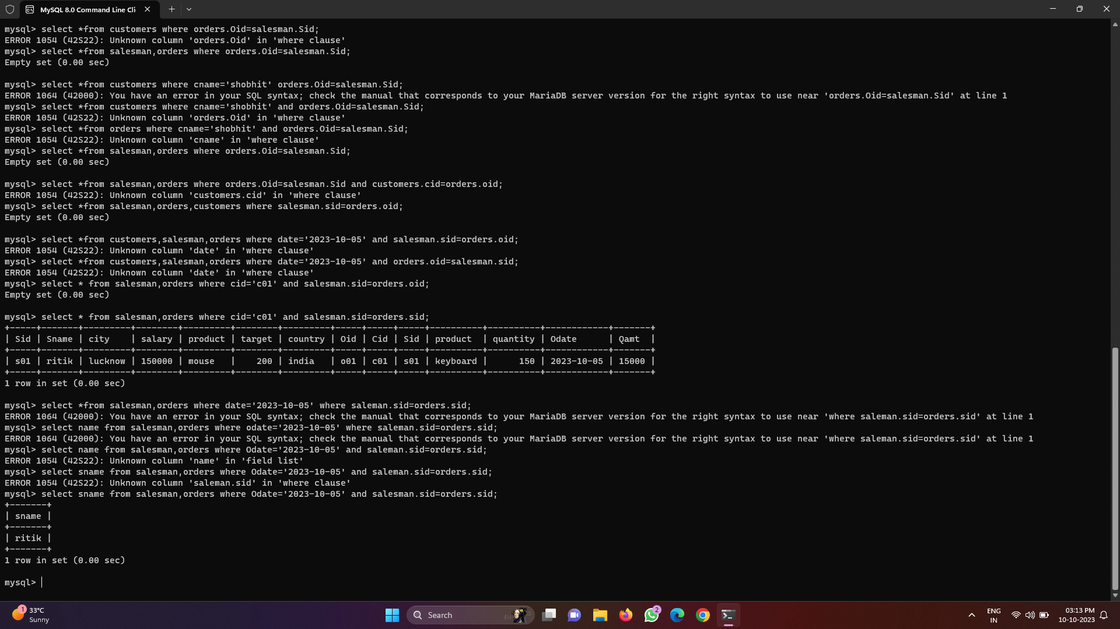

Find the no of customers who purchased a product from salesman live in ‘noida’.

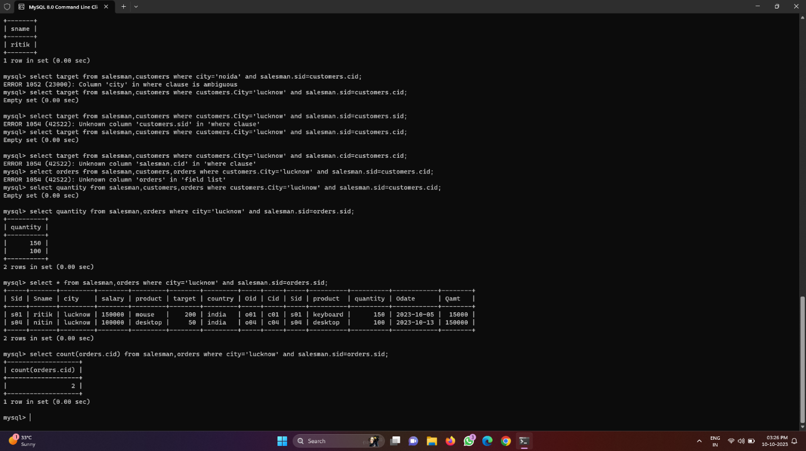

Find the no of salesman who sold a product to customer ‘xyz’.

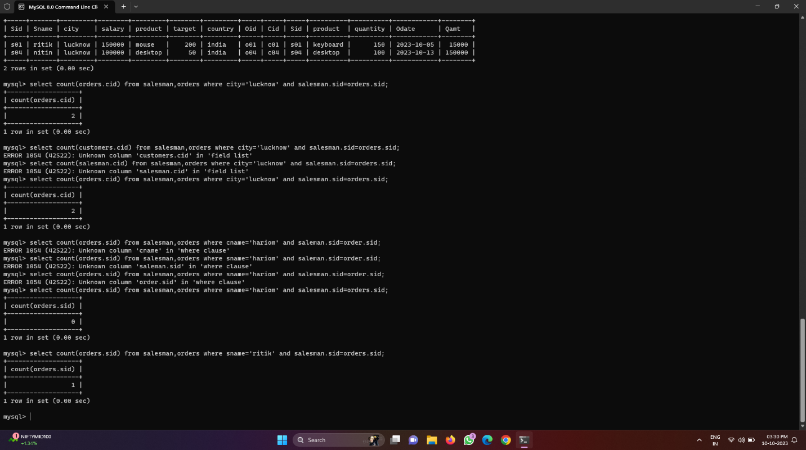

Find the name of customer who purchased a product ‘xyz’.

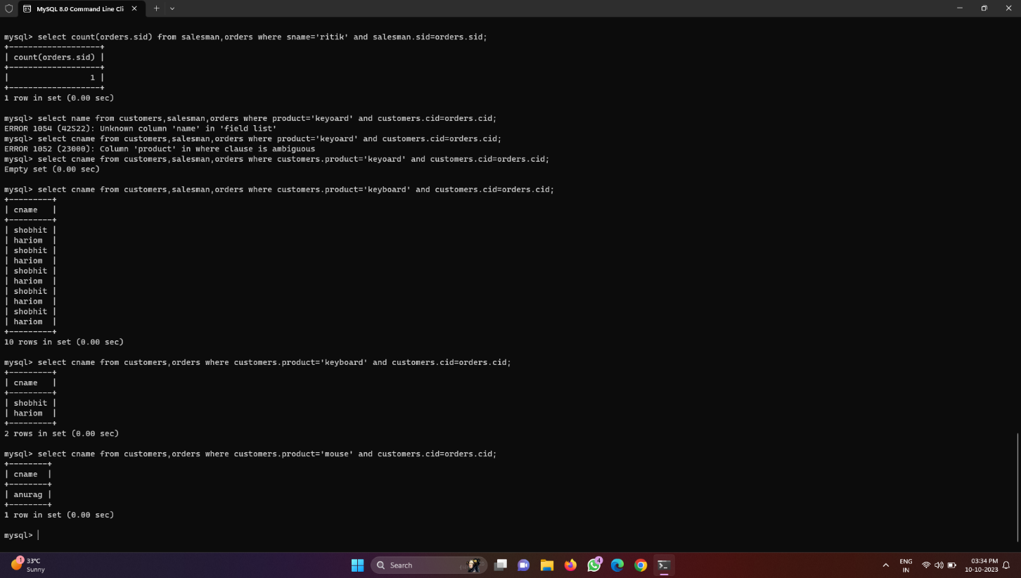

Find the name of salesman who live in the same city as the customer lives.

